Assignment 2

**Title :**

horizontal line**Create a mobile application phone bill calculator.**

# Scenario

1. A new mobile operator wants to build a web page to calculate the bill for the month based on the data usage.
2. The formulae to calculate the bill for different data usage is show below;

|  |  |
| --- | --- |
| Monthly Data Usage | Calculation of Bill |
| Basic Plan with Usage of  up to 1 GB | $10 (Basic Plan Bill) |
| Usage of more than 1GB  and up to 3GB | (Additional Usage in GB multiple by 30) + Basic Plan Bill |
| Usage of more than 3GB | $100 |

1. As shown below, the total bill will be displayed after entering the data usage in the text field on the same page.

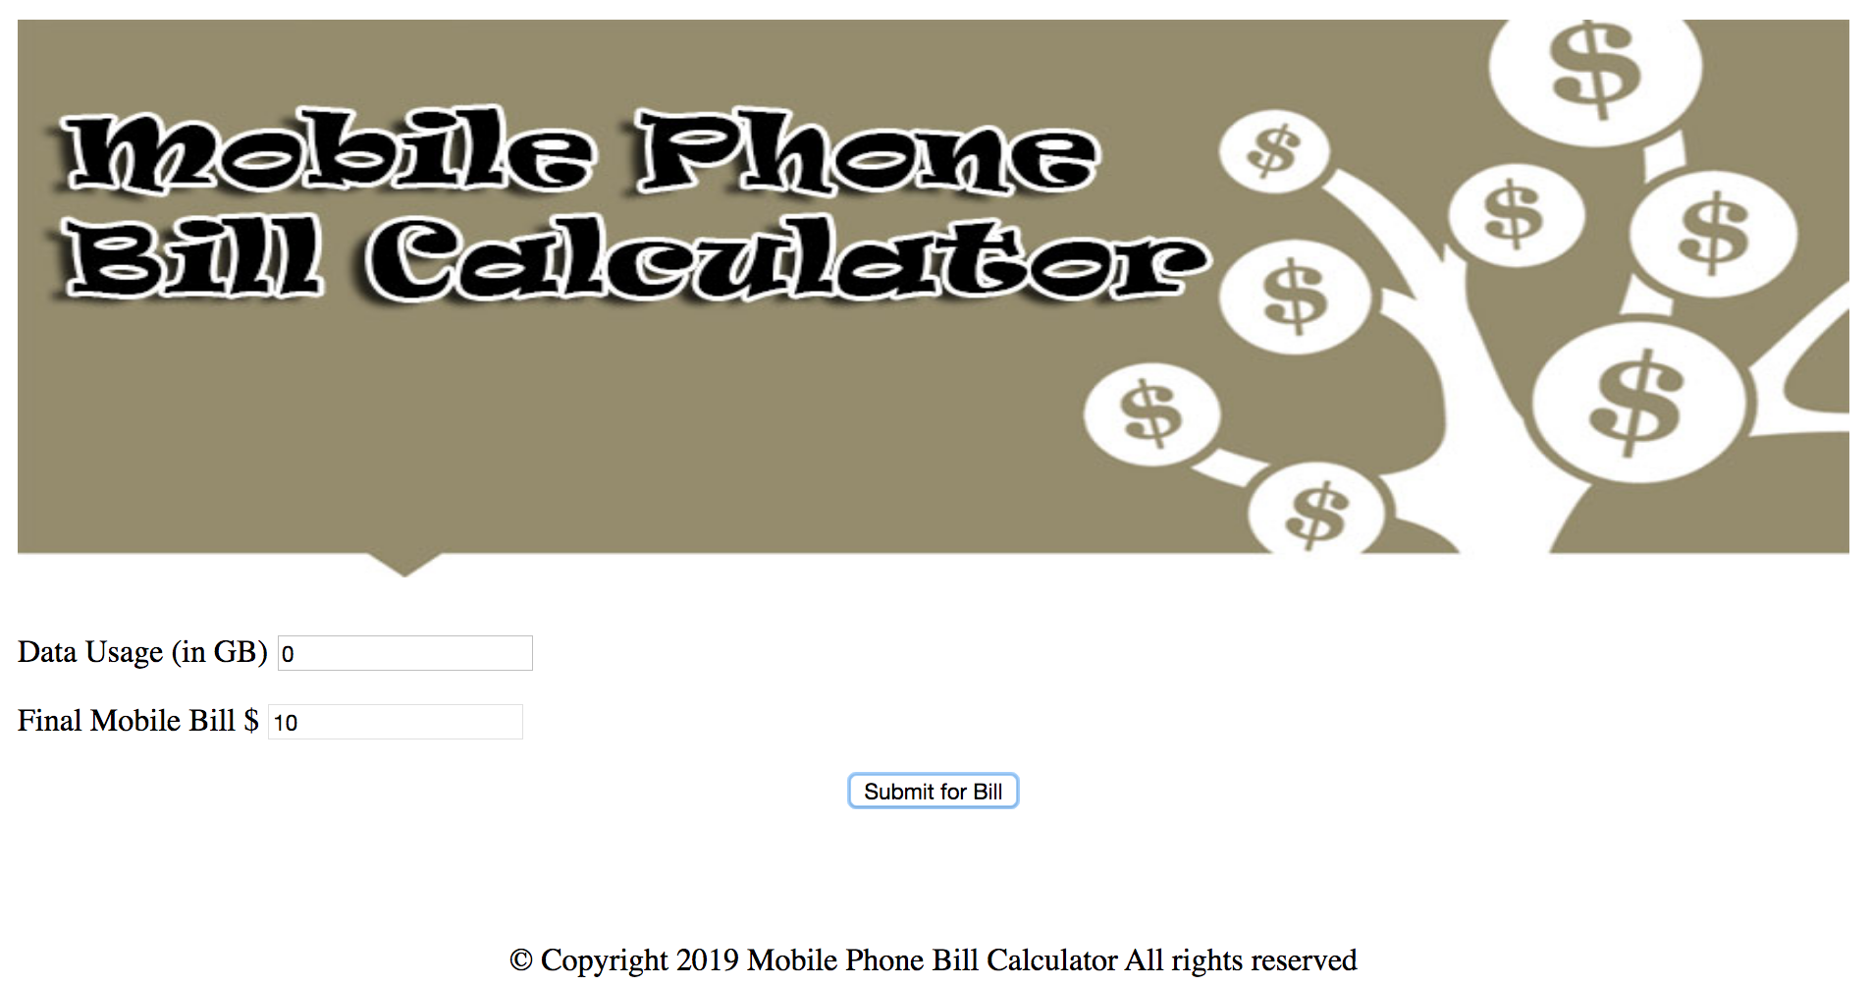

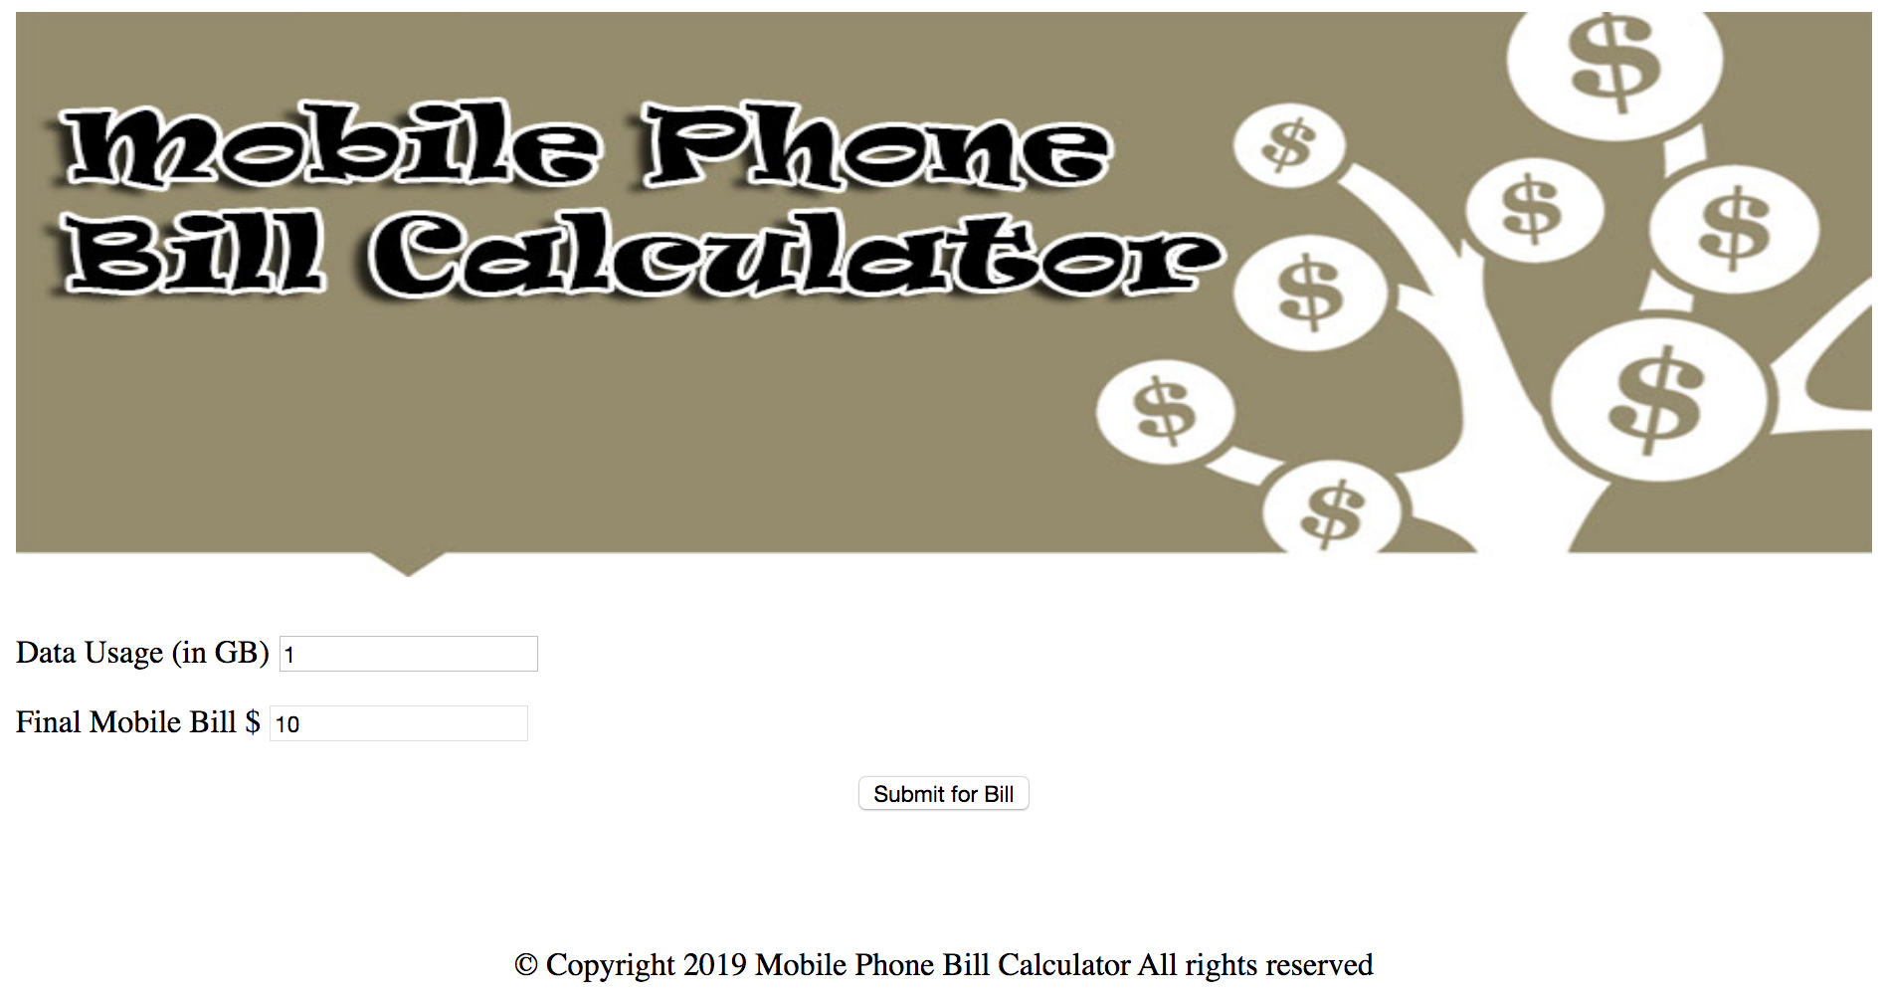

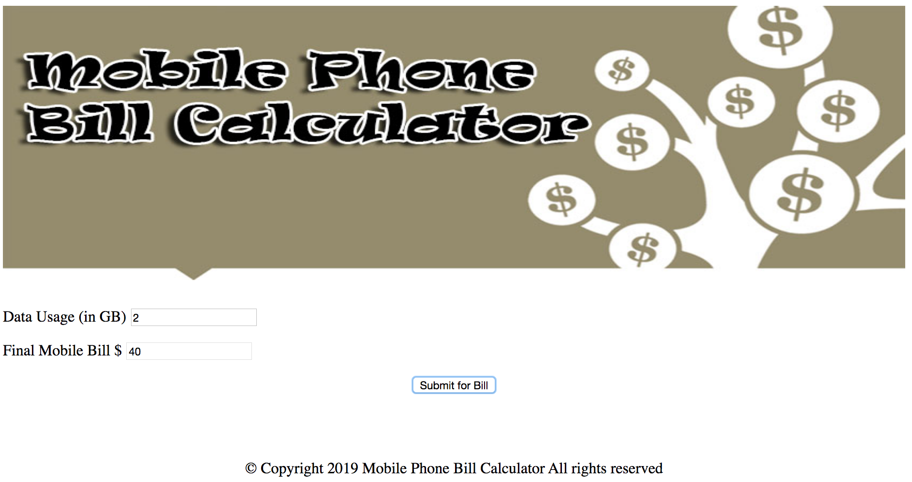

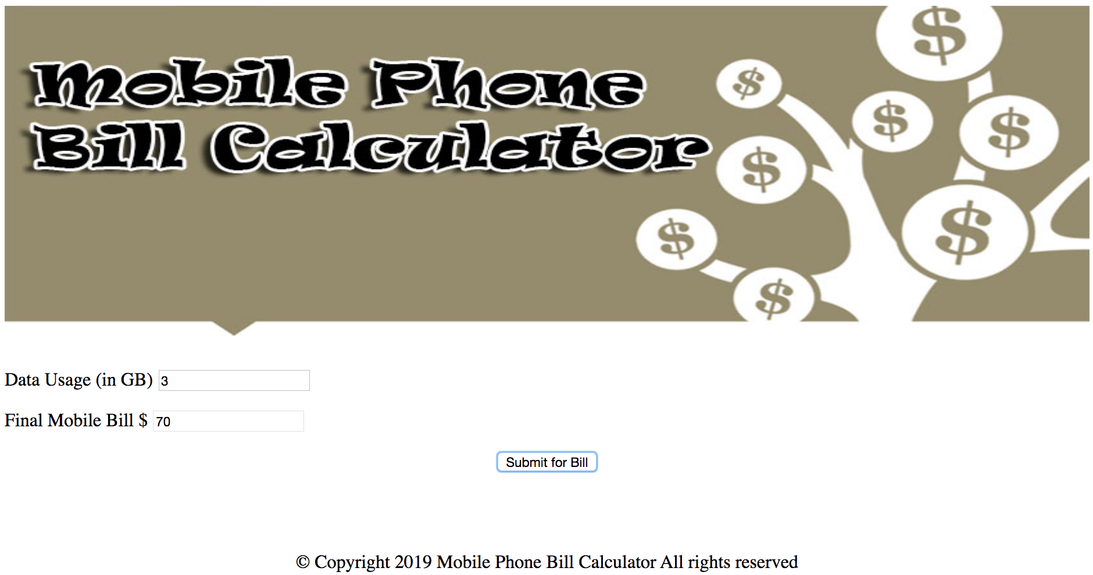

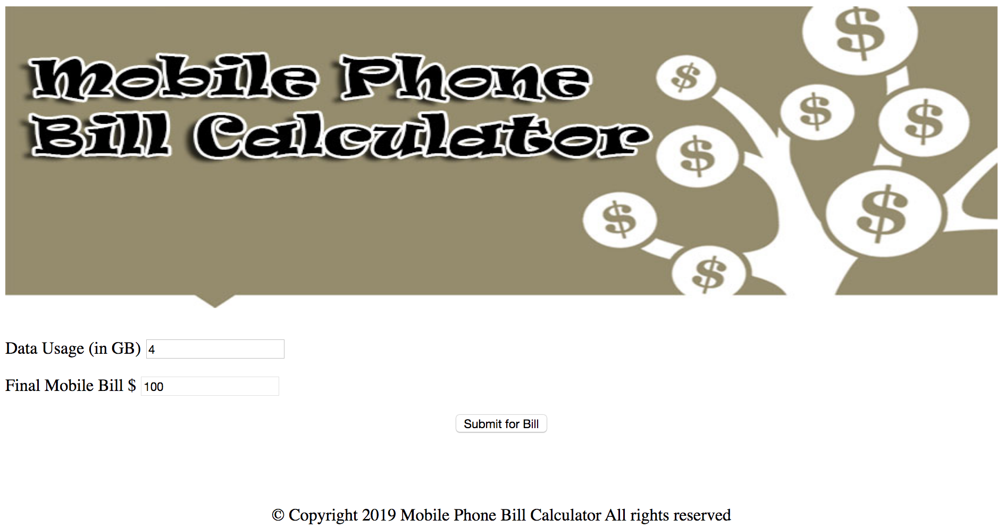

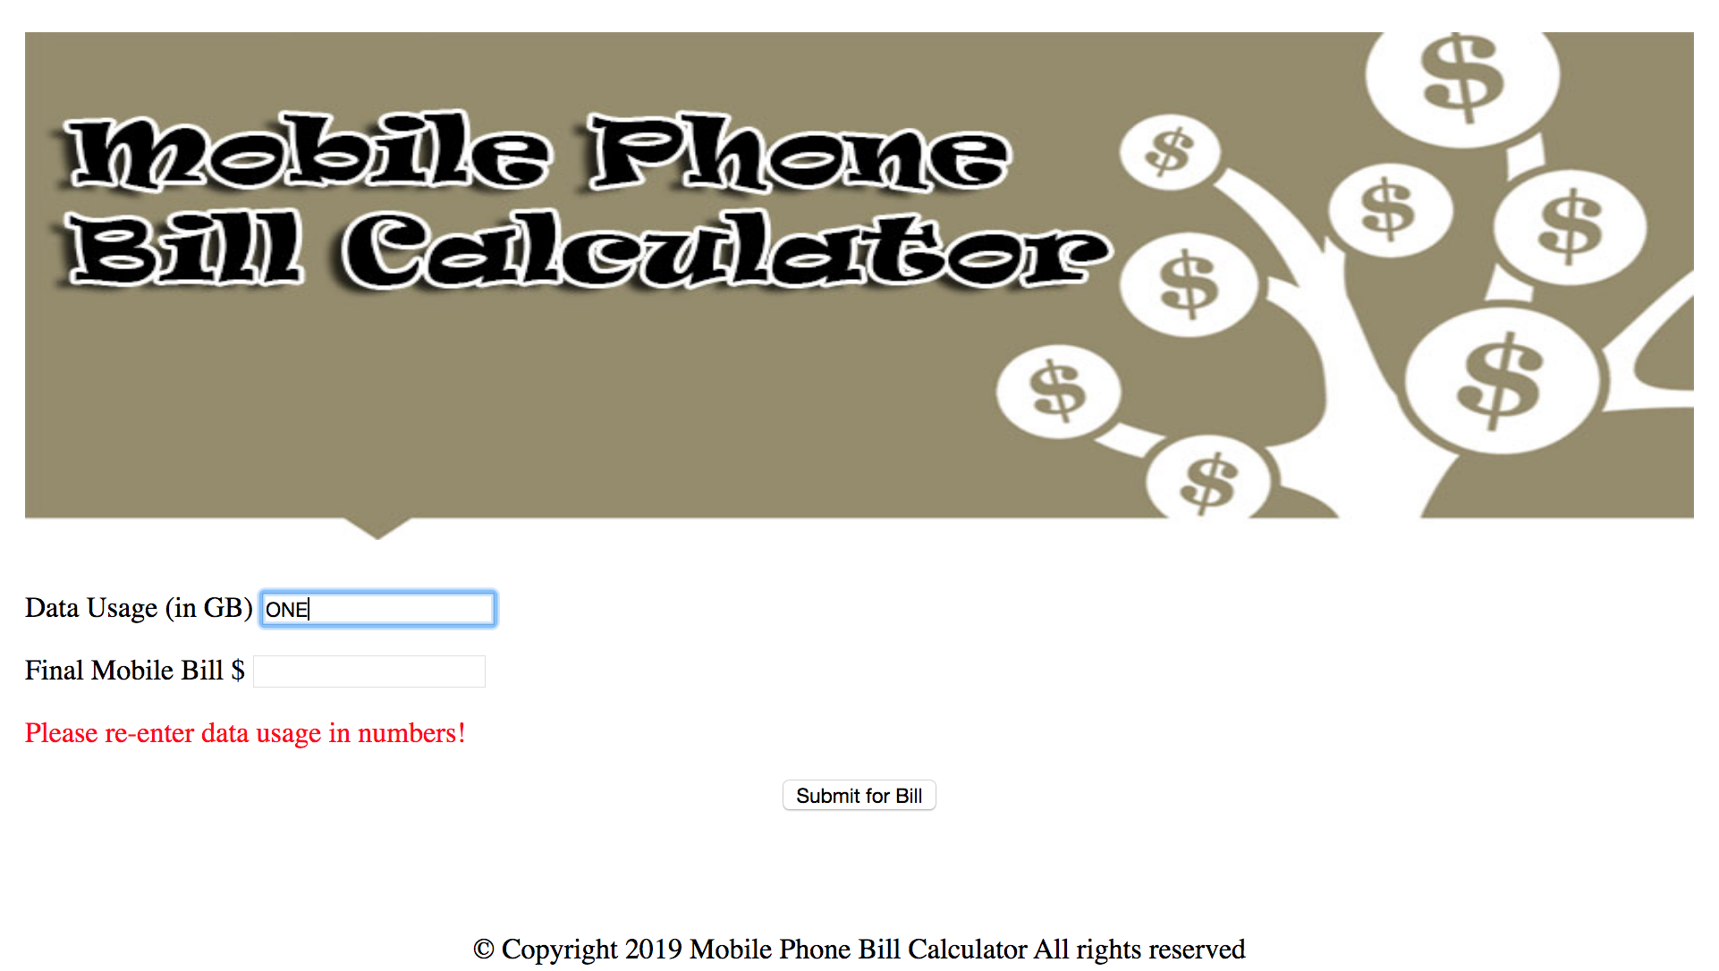

# Part A: Algorithm

1. Write the algorithm for the conditional operations.
2. Get data usage
3. Get bill
4. If(data usage less than or equal to 1 GB) then bill = $10
5. Else if(data usage more than 1 GB and less than or equal to 3 GB) then bill = (data usage – 1) * 30 + 10
6. Else if(data usage more than 3gb) then bill = $100
7. Else Display “invalid input”
8. Display data usage

Part B: Pseudocode

1. Write the pseudocode for the conditional operations.

Get datausage = prompt(“enter data usage”)

Get bill = $0

If(datausage <=1) then

Bill = $10

Else if(1 < datausage <= 3) then

Bill = ((datausage - 1) * 30) + 10

Else if(data usage > 30) then

Bill = $100

Else display invalid input

# Part C: Flowchart

1. Write the flowchart for the following operations.

• input, processing, output.

• sequential

• conditional

• iterative

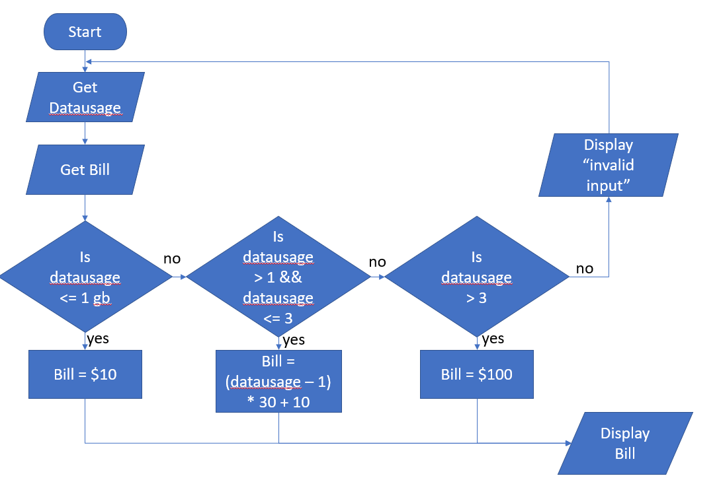

# Part D: Program

1. Write the program and verify that your program is working properly according to the given specifications. Name your program file as index. html

# Code Comments

1. Include at least 5 code comments for the start of program, end of program and the calculation in your program.
2. Copy and paste your whole program, index.html into the box below:

**index.html**

|  |
| --- |
|  |

# Submission

1. Submit your work into a folder named RegNo_yourname_Assignment2. The folder should have the following files:
2. banner.jpg file;
3. index.html file that must be working according to requirements with at least 5 comments; and
4. this Assignment2 template which must be renamed as RegNo_yourname_Assignment2.docx .

You must complete all the following parts in this document:

* Algorithm;
* Pseudo code;
* Flowchart; and
* Program.